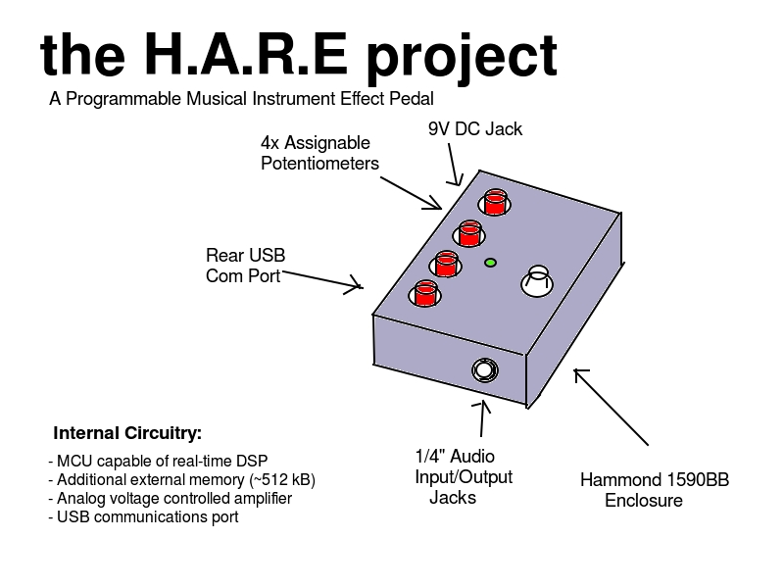
Key Features:- No confusing and complicated digital menus
- User can choose desired effect and upload via USB from a personal computer
- Simple interface eliminates steep learning curve
- Musicians with programming skills can create their own effects

Work Plan:

Milestone | ETC
Develop a working prototype | 3-6 months
Design units for small, beta production runs | 6-9 months
Start developing an online community and user upload program | 9-13 months
Offer beta production units to community members | 13-16 months
Develop additional effects programs | Ongoing
Gather feedback and begin development on 1.0 units | 16-19 months

*NOTE: Time estimates are subject to overlap

Budget Summary:

Item | Cost
Prototype parts and development boards | $100-150 per unit
Beta production runs | $75-125 per unit

Additional Resources:

- Automation for enclosure drilling (drill press, laser cutter, etc.)

Team Members:

- Zachary Clark-Williams (Digital Hardware Design)
- Abram Morphew (Analog/Digital Interfacing)
- Travis Berger (DSP Implementation)
- Joe Hamaker (Product Testing)

Contact Information:

Abram Morphew
em: morphew@pdx.edu
ph: 971.302.0741

